PROJECT DOCUMENTATION
Construction Intelligence Hub
A Centralized Platform for Construction Project Management

Milestone 3 Report
AI Assistants, Predictive Analytics & Computer Vision Integration

Submitted by
PRIYADHARSHINI S

COMPUTER SCIENCE AND ENGINEERING
PANIMALAR ENGINEERING COLLEGE
FINAL YEAR

CERTIFICATE
This is to certify that the project titled “Construction Intelligence Hub” has been successfully carried out by PRIYADHARSHINI S, as part of the requirements for COMPUTER SCIENCE AND ENGINEERING in PANIMALAR ENGINEERING COLLEGE during the academic year FINAL YEAR under the guidance and supervision of the undersigned.

This report is a record of the work carried out by the student(s) for Milestone 3 of the project and is submitted in partial fulfilment of the requirements of the course.
Date: ___________________
Place: ___________________

Signature of Project Guide
[Guide Name & Designation]

ACKNOWLEDGEMENT
We would like to express our sincere gratitude to our project guide, [Guide Name], for the valuable guidance, encouragement, and support extended throughout the development of this project.
We are also thankful to the Department of COMPUTER SCIENCE AND ENGINNERING in PANIMALAR ENGINEERING COLLEGE for providing the necessary resources and environment to carry out this work.
Finally, we extend our heartfelt thanks to our family and friends for their constant support and motivation throughout this project.

CONSTRUCTION INTELLIGENCE HUB

Abstract
Construction Intelligence Hub is a centralized platform designed to streamline the management of construction projects. The application addresses common challenges faced in the construction industry such as manual record keeping, fragmented information, and poor communication between project stakeholders. Milestone 3 of this project delivers a fully integrated, AI-powered platform that unifies project financials, predictive analytics, computer-vision-based safety inspection, and local large-language-model (LLM) assistance behind a secure, authenticated interface. Building on the frontend foundation established in Milestone 1 and the backend/data integration completed in Milestone 2, this milestone introduces an Executive Dashboard, a General AI Assistant and a construction-scoped AI Assistant powered by a locally hosted Ollama LLM, machine-learning-driven Cost Prediction and Delay Risk Prediction engines, a Computer Vision Site Inspection module for automated PPE compliance and hazard detection, a Project Task Management workspace, a Site Safety & Compliance incident logger, and an Export Project Reports module. Together these modules transform the platform from a static prototype into an operational command center for construction project oversight.

1. Introduction
Construction projects are inherently complex, involving multiple stakeholders, resources, schedules, and safety requirements that must be coordinated effectively. The Construction Intelligence Hub project aims to provide a centralized platform for managing construction projects, tracking progress, monitoring resources, and improving communication among project teams.
In Milestone 3, the platform has evolved into a complete, authenticated web application that combines a live Executive Dashboard, dual AI chat assistants powered by a locally hosted Ollama LLM (llama3.2), machine-learning-based cost and delay-risk forecasting, a computer-vision engine for automated PPE compliance and hazard inspection, project task management, safety incident logging, and multi-format report export. This milestone builds directly on the Streamlit-based frontend delivered in Milestone 1 and the backend and data-handling improvements introduced in Milestone 2, bringing all of the platform's intelligence and workflow features together into a single, secure command center.

2. Problem Statement
Construction projects often face several recurring challenges that reduce efficiency and increase costs, including:
- Manual record management leading to errors and delays
- Difficulty tracking project progress in real time
- Material wastage due to lack of visibility into resource availability
- Lack of a centralized source of project information
- Poor communication between teams and stakeholders
The Construction Intelligence Hub aims to solve these problems by bringing all relevant project information together in a single, easy-to-use dashboard

3. Objectives
The key objectives of this project are:
- Manage construction project information in a structured manner
- Monitor project progress through an intuitive interface
- Manage workforce details for each project
- Track material availability and requirements
- Improve overall project planning and coordination
- Provide a simple and user-friendly interface for all stakeholders

4. Scope
The scope of Milestone 3 covers the design and development of the platform's full intelligence and workflow layer: secure sign-in and session management; an Executive Dashboard with live budget, schedule, and safety telemetry; a General AI Assistant and a construction-scoped AI Assistant, both powered by a locally hosted Ollama LLM; an ML-powered Cost Prediction engine; a Delay Risk Prediction engine; a Computer Vision Site Inspection module for PPE compliance and hazard detection; a Project Task Management workspace; a Site Safety & Compliance incident logger; and an Export Project Reports module. Production-grade cloud deployment, live sensor/IoT integration, and multi-tenant administration remain outside the scope of this milestone and are planned for future development phases.

5. System Architecture
The Milestone 3 architecture is a multi-tier application. An authenticated frontend (login and session management) routes requests to a set of feature modules -- the Executive Dashboard, AI Assistants, Cost Prediction, Delay Risk Prediction, Computer Vision Inspection, Project Task Management, Safety & Compliance, and Reports -- each of which reads and writes structured project data. The two AI Assistant modules call a locally hosted Ollama LLM (llama3.2) over its HTTP API, while the Cost Prediction and Delay Risk Prediction modules call trained machine-learning models to generate forecasts from user-supplied project parameters.
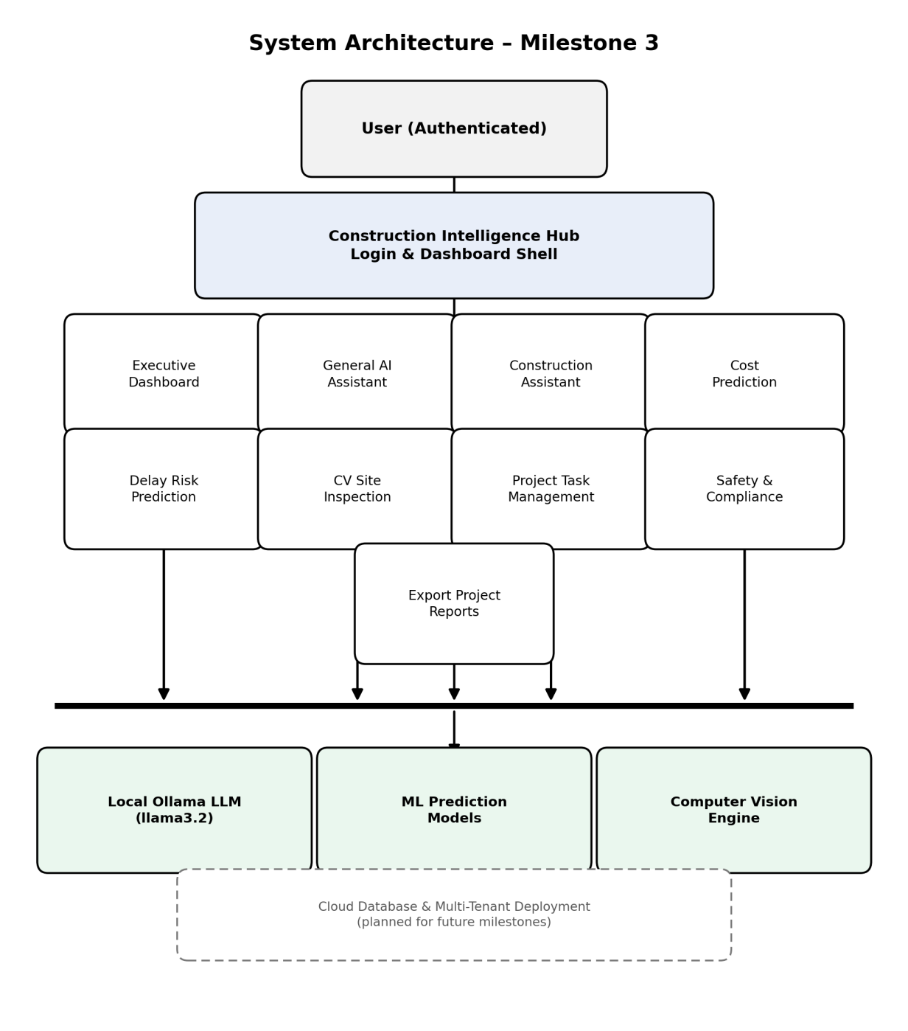
Figure 5.1 – System Architecture Diagram (Milestone 3)

6. Technologies Used
Technology | Purpose
Python | Programming Language
Streamlit | Frontend UI Development
IDLE Python | Code Editor
Ollama (llama3.2) | Local LLM engine powering the General AI Assistant and Construction Assistant
Machine Learning (scikit-learn) | Trained models powering Cost Prediction and Delay Risk Prediction
Computer Vision Engine | Automated PPE compliance and hazard detection from uploaded site photos
Authentication Layer | Secure sign-in with session persistence ("Remember me")

7. Proposed System
With Milestone 3, the Construction Intelligence Hub has become a comprehensive, data-driven platform that goes well beyond the original frontend prototype. Authenticated users land on a live Executive Dashboard and can move between AI-assisted chat, predictive cost and delay forecasting, computer-vision-based site inspection, task management, safety compliance logging, and report export -- all from a single navigation menu. Future work will extend the platform with role-based access for project managers, workers, and administrators, and with real-time data feeds such as weather and material deliveries to support proactive project management.

8. UI Screenshots
This section showcases screenshots captured directly from the running Construction Intelligence Hub application (localhost:8501), covering the Login, Executive Dashboard, General AI Assistant, Construction Assistant, Cost Prediction, Delay Risk Prediction, Computer Vision Site Inspection, Project Task Management, Site Safety & Compliance, Export Project Reports, and About pages.

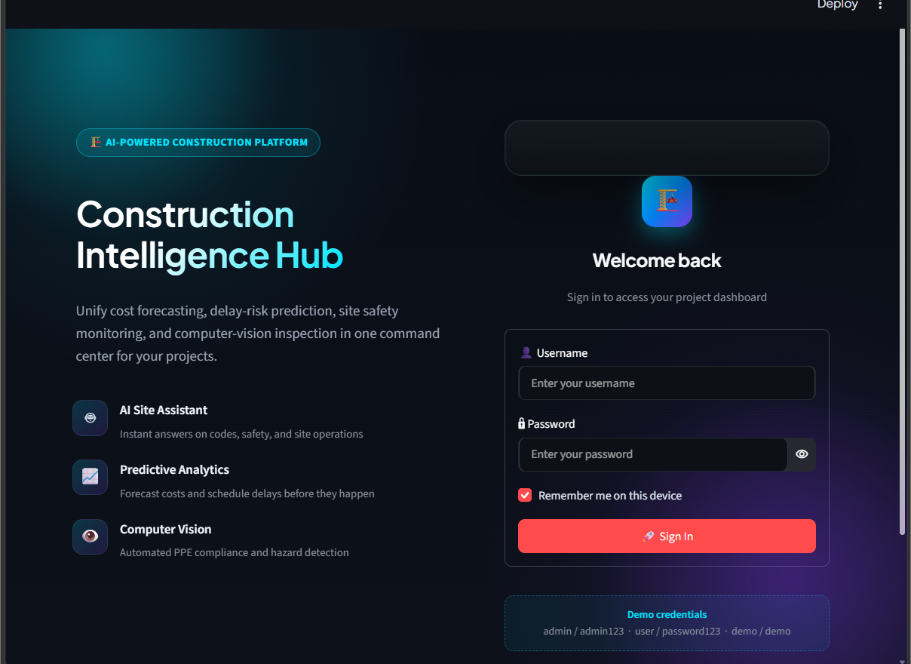
Figure 8.1 – Secure Login

Definition: The Login screen is the entry point of the Construction Intelligence Hub. It authenticates the user before any project data or AI features can be accessed.
Explanation: The page presents the platform's value proposition (cost forecasting, delay-risk prediction, site safety monitoring, and computer-vision inspection) alongside a username/password sign-in form with a “Remember me on this device” option and a set of demo credentials for evaluation purposes.

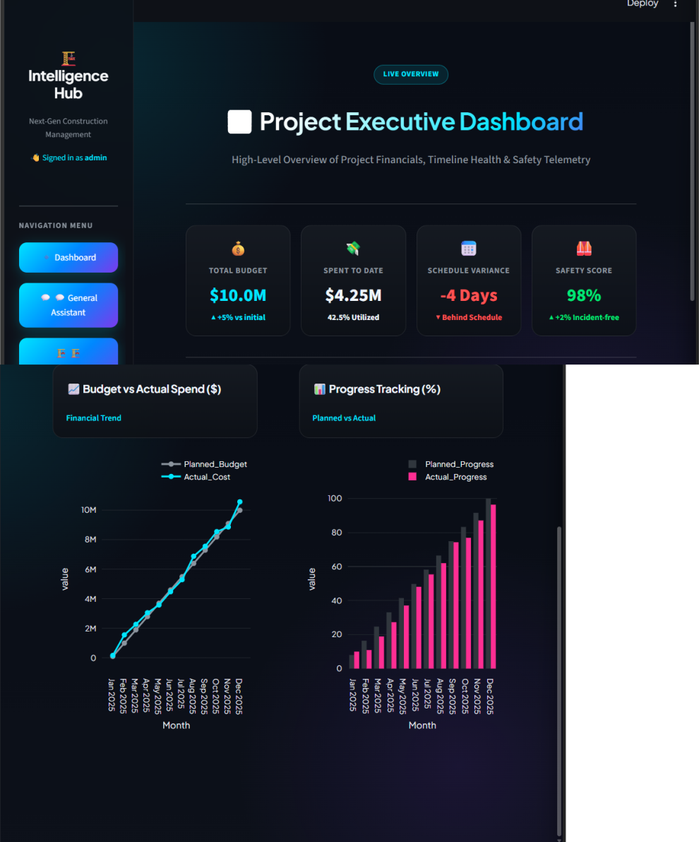
Figure 8.2 – Executive Dashboard

Definition: The Dashboard is the landing screen after sign-in. It gives a real-time, portfolio-wide summary of the active project's financials, schedule health, and safety telemetry.
Explanation: Four metric cards summarize the project: Total Budget ($10.0M), Spent to Date ($4.25M, 42.5% utilized), Schedule Variance (-4 Days, behind schedule), and Safety Score (98%, +2% incident-free). Below them, a line chart compares Planned Budget against Actual Cost by month, and a bar chart compares Planned Progress against Actual Progress by month.

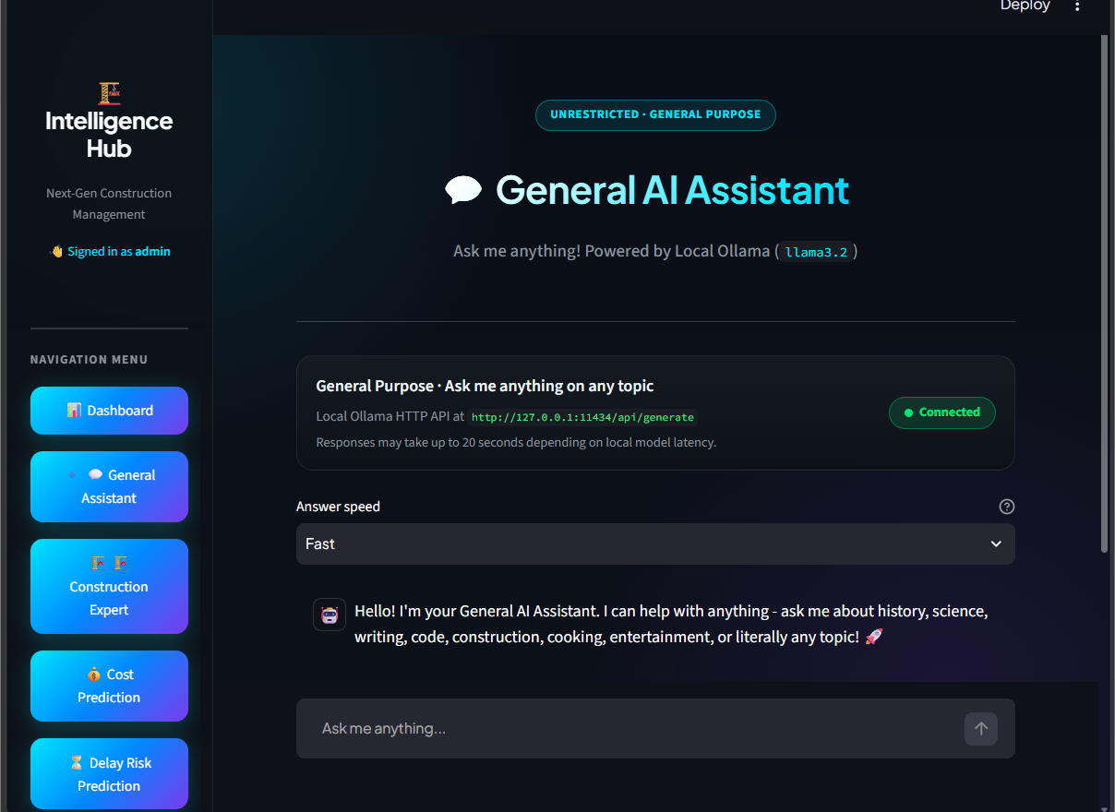
Figure 8.3 – General AI Assistant

Definition: The General AI Assistant is an unrestricted chatbot that can answer questions on any topic, not just construction.
Explanation: The page confirms the assistant is powered by a locally hosted Ollama model (llama3.2) and shows a live “Connected” status for the local HTTP API. An “Answer speed” control lets the user trade off response latency, and the assistant greets the user before accepting free-form questions in the chat box below.

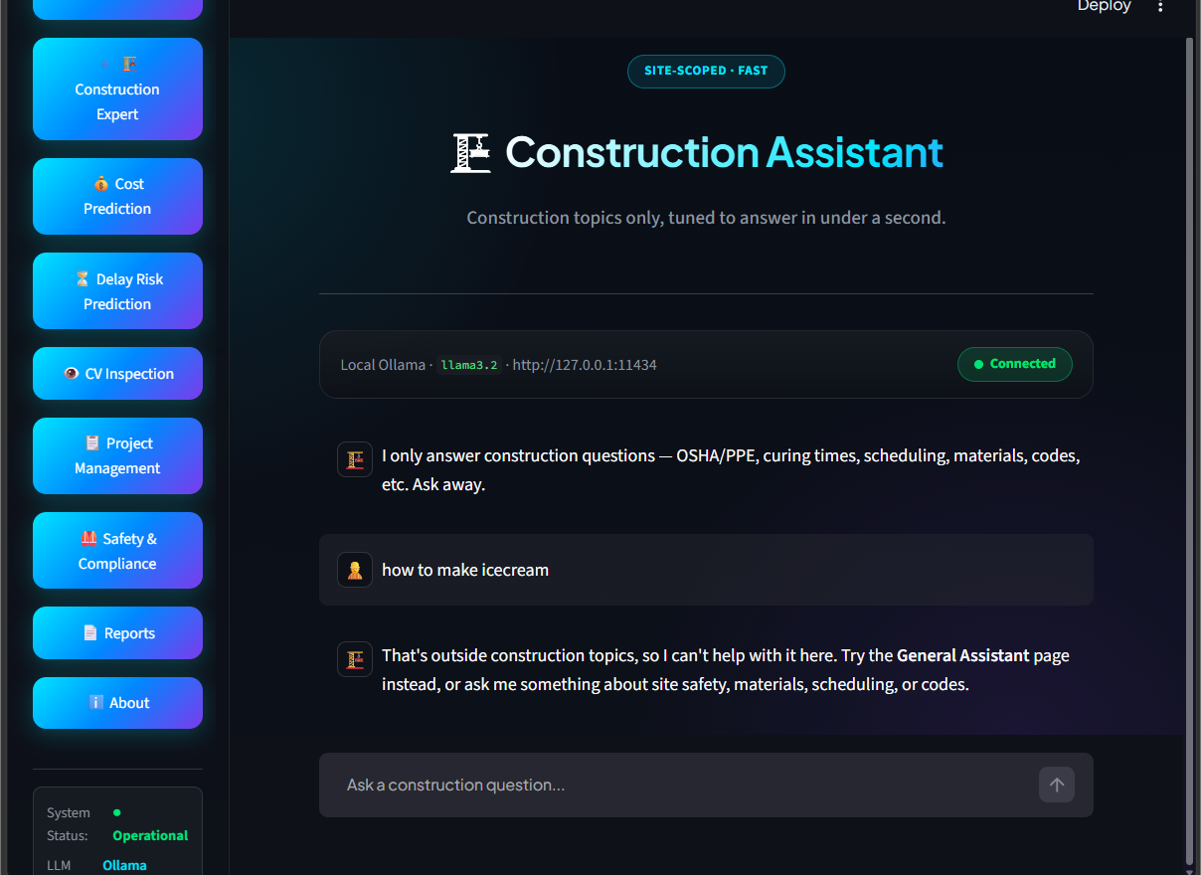
Figure 8.4 – Construction Assistant

Definition: The Construction Assistant is a site-scoped chatbot tuned to answer construction-related questions only, using the same local Ollama LLM.
Explanation: The assistant explicitly limits itself to topics such as OSHA/PPE requirements, curing times, scheduling, materials, and codes. When asked an out-of-scope question (for example, “how to make icecream”), it declines and redirects the user to the General Assistant page instead of answering.

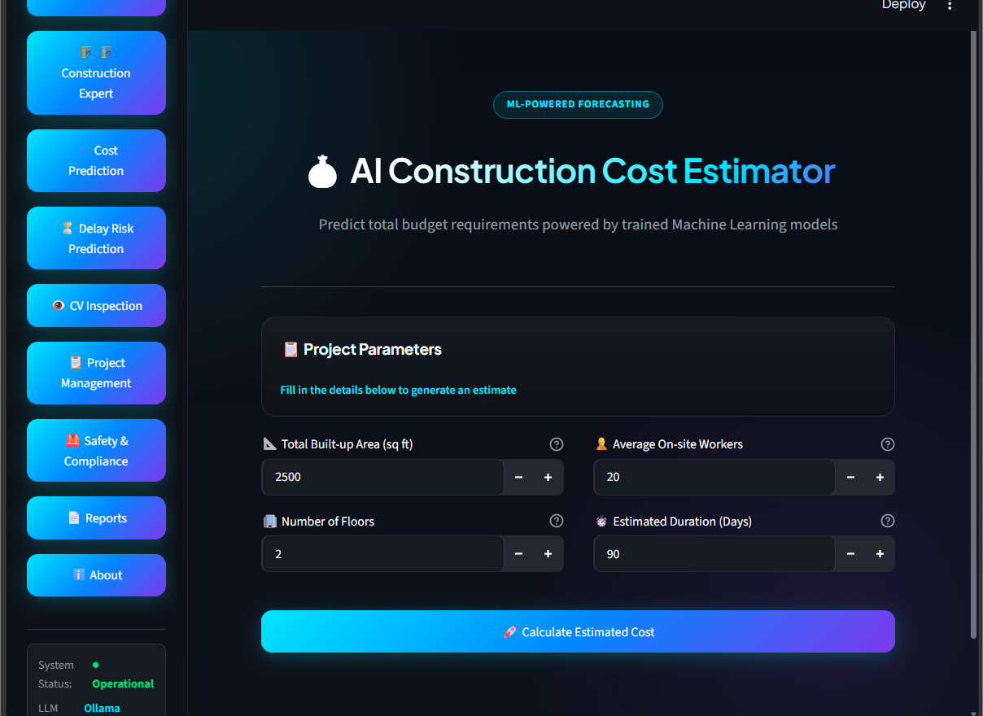
Figure 8.5 – AI Construction Cost Estimator

Definition: The Cost Prediction page forecasts a project's total budget requirement from a set of planning inputs, using a trained machine-learning model.
Explanation: The user fills in Project Parameters -- Total Built-up Area, Average On-site Workers, Number of Floors, and Estimated Duration -- and clicks “Calculate Estimated Cost” to generate an ML-powered budget forecast.

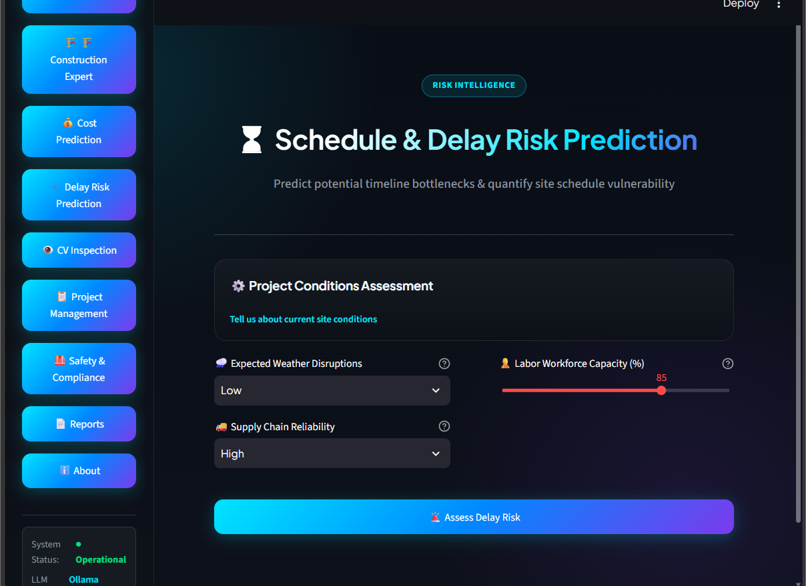
Figure 8.6 – Schedule & Delay Risk Prediction

Definition: The Delay Risk page predicts the likelihood that a project's schedule will slip, based on current site conditions.
Explanation: Under “Project Conditions Assessment,” the user sets Expected Weather Disruptions, Labor Workforce Capacity, and Supplier Reliability, then clicks “Assess Delay Risk” to quantify the project's schedule vulnerability.

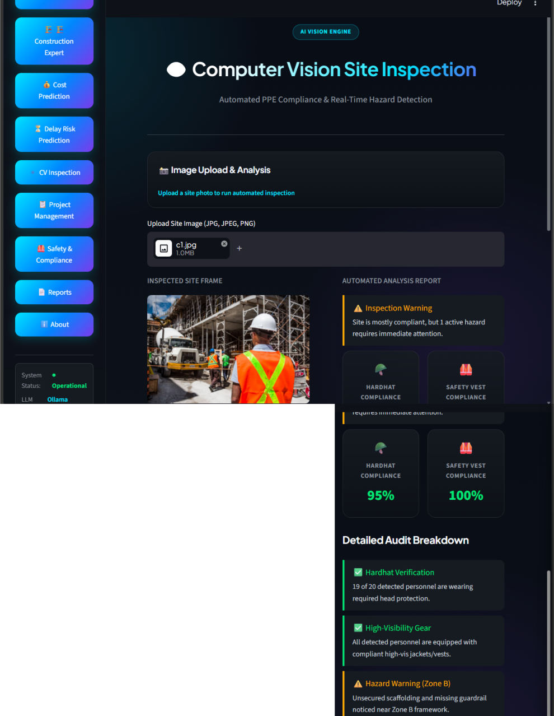
Figure 8.7 – Computer Vision Site Inspection

Definition: The Computer Vision Site Inspection module lets a user upload a construction-site photo for automated PPE compliance and hazard analysis.
Explanation: After a site image is uploaded, the module returns an Inspection Warning summary, Hardhat Compliance (95%) and Safety Vest Compliance (100%) scores, and a Detailed Audit Breakdown covering hardhat verification, high-visibility gear, and any hazard warnings -- such as unsecured scaffolding -- flagged in specific zones of the site.

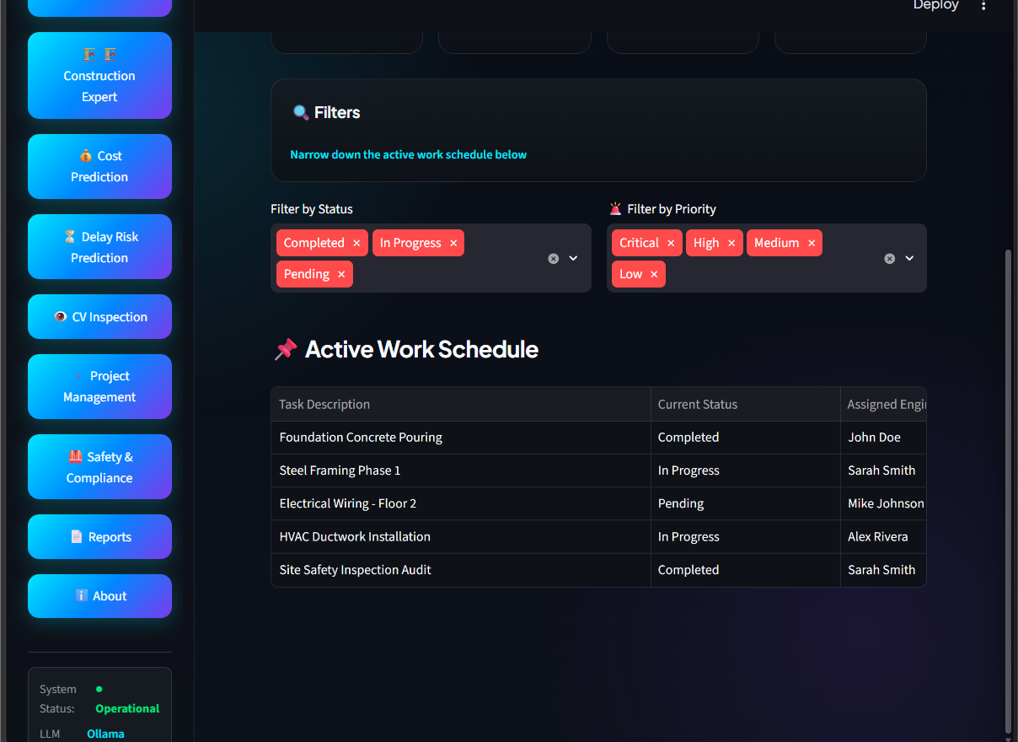
Figure 8.8 – Project Task Management

Definition: The Project Task Management page tracks, filters, and manages site operations and work assignments.
Explanation: Summary cards show Total Tasks, Completed, In Progress, and Pending counts. Filter controls for Status and Priority narrow down the list, and the Active Work Schedule table lists each task's description, current status, and assigned engineer.

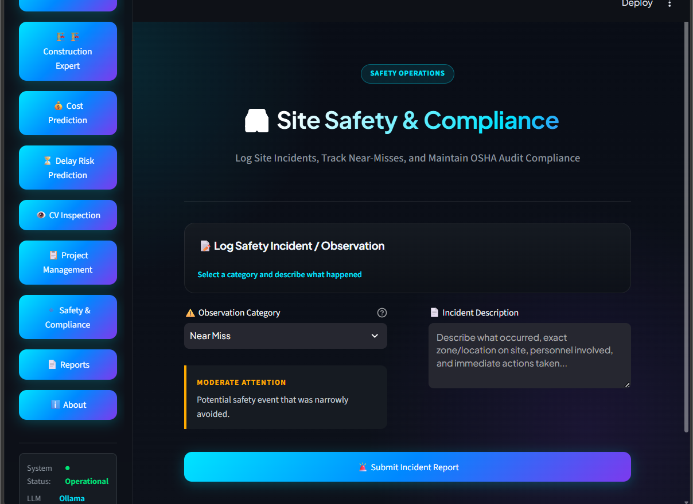
Figure 8.9 – Site Safety & Compliance

Definition: The Site Safety & Compliance page lets users log site incidents and near-misses to maintain OSHA audit compliance.
Explanation: The user selects an Observation Category (for example, Near Miss), enters an Incident Description covering what occurred, the zone/location, personnel involved, and immediate actions taken, and submits the report. An attention-level indicator (for example, “Moderate Attention”) is shown based on the category selected.

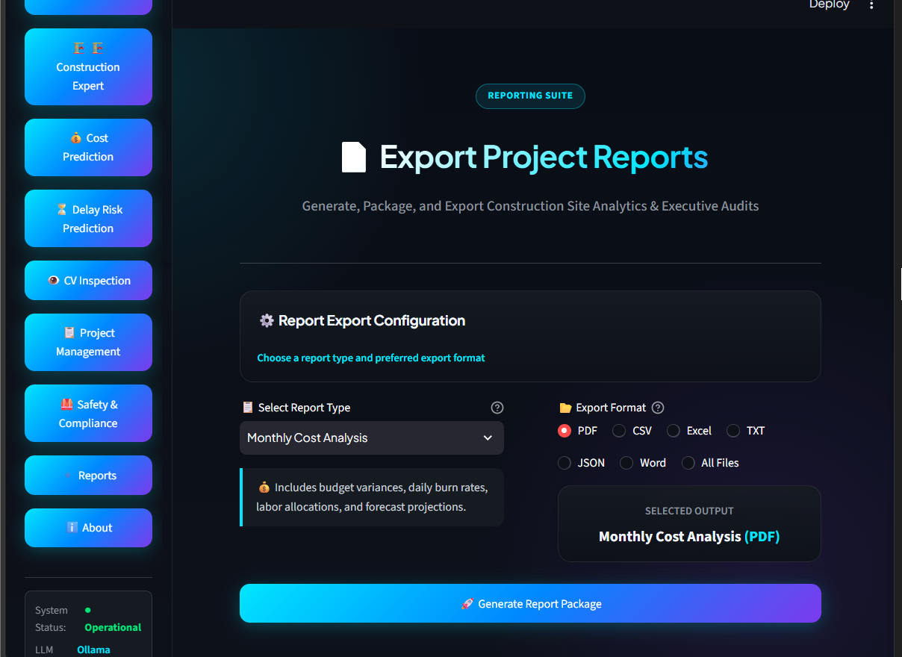
Figure 8.10 – Export Project Reports

Definition: The Export Project Reports page generates, packages, and exports construction site analytics and executive audits.
Explanation: The user selects a Report Type (for example, Monthly Cost Analysis, which includes budget variances, daily burn rates, labor allocations, and forecast projections) and an Export Format (PDF, CSV, Excel, TXT, JSON, Word, or All Files), then clicks “Generate Report Package” to produce the selected output.

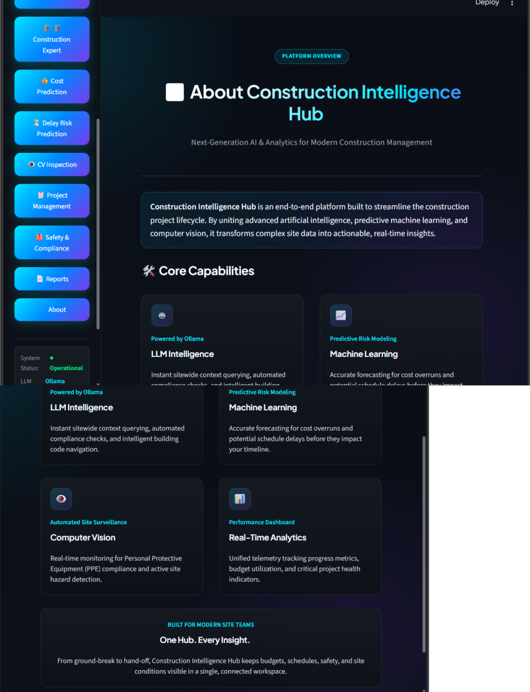
Figure 8.11 – About Construction Intelligence Hub

Definition: The About page describes the platform's purpose and the core capabilities that power it.
Explanation: The page introduces Construction Intelligence Hub as an end-to-end platform uniting artificial intelligence, predictive machine learning, and computer vision. Four capability cards summarize the platform: LLM Intelligence (powered by Ollama, for instant sitewide querying and compliance checks), Machine Learning (predictive risk modeling for cost overruns and schedule delays), Computer Vision (automated site surveillance for PPE compliance and hazard detection), and Real-Time Analytics (a unified performance dashboard for progress, budget, and project health).

9. Module Description
The application is organized into the following modules:

Module | Description
Login | Provides secure authentication with a username/password sign-in form and an optional “Remember me” session.
Dashboard | Shows a real-time overview of the active project's budget, schedule variance, and safety score, with supporting charts.
General AI Assistant | An unrestricted chatbot, powered by a local Ollama LLM, that can answer questions on any topic.
Construction Assistant | A construction-scoped chatbot, tuned to answer only site-related questions using the same local LLM.
Cost Prediction | Forecasts a project's total budget requirement from planning inputs using a trained machine-learning model.
Delay Risk Prediction | Assesses the likelihood of schedule slippage based on current site conditions.
CV Inspection | Analyzes an uploaded site photo to automatically assess PPE compliance and flag safety hazards.
Project Management | Tracks, filters, and manages site tasks and work assignments.
Safety & Compliance | Lets users log safety incidents and near-misses to maintain OSHA audit compliance.
Reports | Generates and exports packaged project analytics and executive audits in multiple formats.
About | Describes the platform's purpose, core capabilities, and the technologies that power it.

9.1 Login
The Login page is the entry point of the application. Users sign in with their credentials before any dashboard or AI feature becomes accessible, and can opt to stay signed in on their device.

9.2 Dashboard
The Dashboard is the landing page after sign-in. It provides an at-a-glance view of the project through metric cards (Total Budget, Spent to Date, Schedule Variance, Safety Score) and charts comparing Planned Budget vs. Actual Cost and Planned Progress vs. Actual Progress by month.

9.3 General AI Assistant
This section provides a general-purpose chat interface connected to a locally hosted Ollama model (llama3.2). Users can ask about anything -- construction or otherwise -- and adjust an “Answer speed” setting to balance response latency.

9.4 Construction Assistant
This section restricts its answers to construction topics such as OSHA/PPE requirements, curing times, scheduling, materials, and codes, and redirects out-of-scope questions to the General AI Assistant.

9.5 Cost Prediction
Users enter Total Built-up Area, Average On-site Workers, Number of Floors, and Estimated Duration to receive an ML-powered estimate of total construction cost.

9.6 Delay Risk Prediction
Users set Expected Weather Disruptions, Labor Workforce Capacity, and Supplier Reliability to receive a quantified assessment of the project's schedule delay risk.

9.7 CV Inspection
This section lets users upload a construction-site photograph and returns Hardhat Compliance and Safety Vest Compliance percentages, along with a detailed audit breakdown that flags issues such as unsecured scaffolding in specific site zones.

9.8 Project Management
This section shows task totals by status (Completed, In Progress, Pending), lets users filter the active work schedule by status and priority, and lists each task with its description, current status, and assigned engineer.

9.9 Safety & Compliance
This section provides a form to select an Observation Category, describe what occurred (including zone/location, personnel involved, and immediate actions taken), and submit an incident report for the audit trail.

9.10 Reports
This section lets users choose a Report Type (such as Monthly Cost Analysis) and an export format (PDF, CSV, Excel, TXT, JSON, or Word), then generate the report package.

9.11 About
This section introduces Construction Intelligence Hub and summarizes its four core capabilities: LLM Intelligence (Ollama), Machine Learning (predictive risk modeling), Computer Vision (automated site surveillance), and Real-Time Analytics (a unified performance dashboard).

10. Future Enhancements
The following features are planned for future milestones:
- Cloud database and multi-tenant deployment
- Role-based access for project managers, workers, and administrators
- Material demand forecasting
- Equipment monitoring
- Live weather and IoT sensor integration
- Worker attendance tracking
- Multi-project portfolio view across sites
- Push notifications and automated alerting
- Mobile application companion

11. Conclusion
Construction Intelligence Hub provides an easy and efficient way to manage construction projects. This milestone (Milestone 3) delivers a fully integrated, AI-powered platform -- combining secure authentication, a live Executive Dashboard, local-LLM-powered General and Construction AI Assistants, machine-learning-based Cost Prediction and Delay Risk Prediction, Computer Vision Site Inspection, Project Task Management, Site Safety & Compliance logging, and multi-format Report Export -- into a single, authenticated command center. Future milestones will extend the platform with cloud database and multi-tenant deployment, role-based access control, and live sensor/IoT data feeds to build a complete, production-ready project management solution.

12. REFERENCES
- Streamlit Documentation – https://docs.streamlit.io
- Python Software Foundation – https://www.python.org
- GitHub Documentation – https://docs.github.com
- Ollama Documentation – https://ollama.com
- scikit-learn Documentation – https://scikit-learn.org

